Stat 135 Homework 10

1. Question 21:
   1. We use normal theory to run a two-sided t-test, with alternative: Xbar != YBar. We get a t-statistic of 2.07. Since p-value > 0.05, we fail to reject H0 at the 0.05 significance level.
   2. Using the nonparametric MW Rank test, we get R* = 80. Looking at the table, the critical value for a two-sided test with alpha = 0.05 is 78. Since R* = 80, we fail to reject at the 0.05 significance level.
   3. We have no reason to assume the data is normally distributed, and the sample size is small. Hence, we should use the non-parametric test.
   4. PiHat = 0.25
   5. SE of PiHat = 0.116
   6. 90% Confidence Interval for PiHat: (0.04, 0.43)
2. Question 39:
   1. 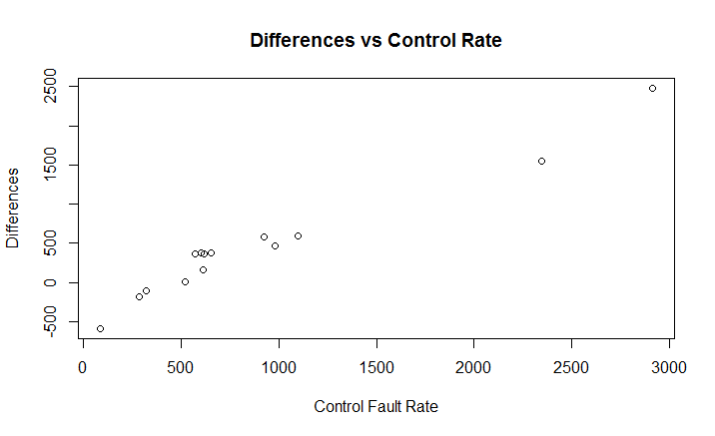

We observe that the differences increase as the control fault rate increases, implying that the test rate tended to not increase as much (or possibly decreased) as the control rate increased.

* 1. Dbar = 461.29, SD of Dbar = 202.53 and a 95% confidence interval = (25.1, 828.6)
  2. Dmedian = 368.5, a 95% confidence interval = (186, 712). We can see the 95% CI for the median is tighter than the CI for the mean. However, neither interval contains 0.
  3. We have no reason to assume the data is normally distributed, and the sample size is small. Hence, we should use the non-parametric test.

Paired t-test: t-statistic = 2.28. p-value is about 0.04, so we reject at 0.05 significance level.   
  
Nonparametric Signed Rank Test: Since W- < W+, we use W- as our test statistic. For n = 14, we see W- = 17 lies above the critical value for alpha = 0.02 for a two-sided test, but below the 0.05 critical value. Hence, the p-value > 0.02 and < 0.05 and we reject at the 0.05 significance level.

1. Question 40:
2. t-statistic = 3.3. P-value is about 0.01, so we reject at 0.05 significance level.
3. Since W- < W+, we use W- as our test statistic. For n = 10, we see W- = 5 lies exactly on the critical value for alpha = 0.02 for a two-sided test. Hence, the p-value is about 0.02 and we reject at the 0.05 significance level.

R Code:

#Question 21, Chapter 11

#Part a):

type1 <- c(3.03, 5.53, 5.60, 9.30, 9.92, 12.51, 12.95, 15.21, 16.04, 16.84) #Xi

type2 <- c(3.19, 4.26, 4.47, 4.53, 4.67, 4.69, 12.78, 6.79, 9.37, 12.75) #Yi

n <- length(type1)

m <- length(type2)

df <- m + n - 2

sp2<- ((n-1)*var(type1) + (m-1)*var(type2))/df #Assuming variance of type 1 = type 2.

#Notice that sp2 will have the same value if we assuming unequal variances,

#because the sample sizes are equal.

t_statistic <- (mean(type1) - mean(type2))/(sqrt(sp2*(1/n + 1/m)))

p_value <- pt(t_statistic, df, lower.tail = FALSE)*2

#This is a two-sided test, Alternative: Xbar != YBar

#Since p-value > 0.05, we fail to reject H0 at the 0.05 significance level.

check = t.test(type1, type2, alternative = "two.sided")

#Part b):

both <- c(3.03, 5.53, 5.60, 9.30, 9.92, 12.51, 12.95, 15.21, 16.04, 16.84,

3.19, 4.26, 4.47, 4.53, 4.67, 4.69, 12.78, 6.79, 9.37, 12.75)

rank_type1 <- rank(both)[1:10]

rank_type2 <- rank(both)[11:20]

rprime <- n*(m + n + 1) - sum(rank_type1)

rstar <- min(rprime, sum(rank_type1))

#Looking at the table, the critical value for a two-sided test with alpha = 0.05 is 78.

#Since R* = 80, we fail to reject at the 0.05 significance level.

check <- wilcox.test(type1, type2, alternative = "two.sided")

#Part c):

#We have no reason to assume the data is normally distributed, and the sample size is small.

#Hence, we should use the non-parametric test.

#Part d):

#Pi is estimated by PiHat.

estimate_pi <- function(x, y) {

pihat <- 0

n <- length(x)

m <- length(y)

for (i in 1:n) {

for (j in 1:m) {

if (x[i] < y[j])

pihat = pihat + 1

}

}

pihat <- (1/(m*n))*pihat

return (pihat)

}

pihat <- estimate_pi(type1, type2) #PiHat = 0.25

#Part e):

bootstrap_pihat <- rep(0, 10000)

for (i in 1:10000){

sample_type1 <- sample(type1, n, replace = TRUE)

sample_type2 <- sample(type2, m, replace = TRUE)

bootstrap_pihat[i] = estimate_pi(sample_type1, sample_type2)

}

mean_pihat = mean(bootstrap_pihat)

se_pihat = sd(bootstrap_pihat)

#Part f):

bootstrap_pihat <- sort(bootstrap_pihat)

lower_delta = bootstrap_pihat[0.05*10000] - pihat

upper_delta = bootstrap_pihat[0.950*10000] - pihat

confidence_interval = pihat - c(upper_delta, lower_delta) #(0.04, 0.43)

#Question 39, Chapter 11

#Part a)

phonelines <- read.csv("phonelines.csv", header=TRUE, sep = ",")

differences <- phonelines$control - phonelines$test #Done this way to get positive Dbar.

n <- length(phonelines$test)

plot(phonelines$control, differences, main = "Differences vs Control Rate", ylab = "Differences",

xlab = "Control Fault Rate")

#We observe that the differences increase as the control fault rate increases,

#implying that the test rate tended to not increase as much (or possibly decreased)

#as the control rate increased.

#Part b)

Dbar <- mean(differences)

SD_Dbar <- sd(differences)/sqrt(n)

bootstrap_Dbar <- rep(0, 10000)

for (i in 1:10000){

sample_control <- sample(phonelines$control, n, replace = TRUE)

sample_test <- sample(phonelines$test, n, replace = TRUE)

bootstrap_Dbar[i] = mean(sample_control - sample_test)

}

bootstrap_Dbar <- sort(bootstrap_Dbar)

lower_delta = bootstrap_Dbar[0.025*10000] - Dbar

upper_delta = bootstrap_Dbar[0.975*10000] - Dbar

confidence_interval = Dbar - c(upper_delta, lower_delta) #(25.1, 828.6), a 95% CI.

#Part c)

Dmedian <- median(differences)

bootstrap_Dmedian <- rep(0, 10000)

for (i in 1:10000){

sample_control <- sample(phonelines$control, n, replace = TRUE)

sample_test <- sample(phonelines$test, n, replace = TRUE)

bootstrap_Dmedian[i] = median(sample_control - sample_test)

}

bootstrap_Dmedian <- sort(bootstrap_Dmedian)

lower_delta = bootstrap_Dmedian[0.025*10000] - Dmedian

upper_delta = bootstrap_Dmedian[0.975*10000] - Dmedian

confidence_interval = Dmedian - c(upper_delta, lower_delta) #(186, 712)

#We can see the 95% CI for the median is tighter than the CI for the mean.

#However, neither interval contains 0.

#Part d)

#We have no reason to assume the data is normally distributed, and the sample size is small.

#Hence, we should use the non-parametric test.

t_statistic = Dbar/SD_Dbar #Under H0

p_value = pt(t_statistic, n-1, lower.tail = FALSE)*2

#P-value is about 0.04, so we reject at 0.05 significance level.

check <- t.test(phonelines$test, phonelines$control, alternative = "two.sided", paired = TRUE)

ranks <- rank(abs(differences))

signs <- differences/abs(differences)

signed_ranks <- ranks*signs

Wplus <- sum(signed_ranks[signed_ranks > 0])

Wminus <- abs(sum(signed_ranks[signed_ranks < 0]))

#Since W- < W+, we use W- as our test statistic.

#For n = 14, we see W- lies above the critical value for alpha = 0.02 for a two-sided test.

#Hence, the p-value > 0.02 and < 0.05 and we reject at the 0.05 significance level.

check <- wilcox.test(phonelines$test, phonelines$control, alternative = "two.sided", paired = TRUE)

#Question 40

#Part c)

magfield <- read.csv("magfield.csv", header=TRUE, sep = ",")

differences <- magfield$absent - magfield$present #Done this way to get positive Dbar.

n <- length(magfield$present)

Dbar <- mean(differences)

SD_Dbar <- sd(differences)/sqrt(n)

t_statistic = Dbar/SD_Dbar #Under H0

p_value = pt(t_statistic, n-1, lower.tail = FALSE)*2

#P-value is about 0.01, so we reject at 0.05 significance level.

check <- t.test(magfield$present, magfield$absent, alternative = "two.sided", paired = TRUE)

#Part d)

ranks <- rank(abs(differences))

signs <- differences/abs(differences)

signed_ranks <- ranks*signs

Wplus <- sum(signed_ranks[signed_ranks > 0])

Wminus <- abs(sum(signed_ranks[signed_ranks < 0]))

#Since W- < W+, we use W- as our test statistic.

#For n = 10, we see W- lies exactly on the critical value for alpha = 0.02 for a two-sided test.

#Hence, the p-value is 0.02 and we reject at the 0.05 significance level.

check <- wilcox.test(magfield$present, magfield$absent, alternative = "two.sided", paired = TRUE)